WORK EXPERIENCE JOURNAL
This journal will help you plan and track your work experience. You’ll need to fill in some sections before, during, and after your work experience.

A) COMPLETE BEFORE PLACEMENT
- Work experience profile
Student name:
Dates of experience:
Start date:  Monday 29th June 2025 | End date:  Friday 3rd July 2025
Working hours:
From: | To:
Things to prepare:
Lunchtime arrangements (e.g. packed lunch, provided by work, buying lunch yourself)

Workwear (e.g. are you required to wear particular clothing such as a suit, high visibility jacket, company clothing, or a uniform?)

Will this be provided for you? Yes / No

Travel arrangements:
Mode of travel (e.g. car, train, walk, bus) and journey length
Main contact:
The name and contact details of the person you are reporting to during your work experience:

- Protocols
What will I do if…
I wake up and feel too unwell to go to work?

I realise that I’m going to be late?

I’m concerned about part of my work experience?

- Health and safety
Sign names:
A) Danger: Obstacles
B) Emergency exit
C) No smoking
D) Fire extinguisher
E) First aid
F) No naked flames
G) Safety boots must be worn
H) Safety helmet must be worn
I) Eye protection must be worn
J) No access for pedestrians
K) Danger: Flammable material
L) Danger: Electricity
Match the health and safety sign name to the graphic:
 |  | 
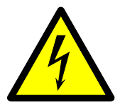 | 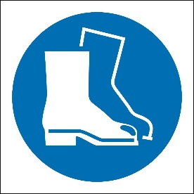 | 
 | 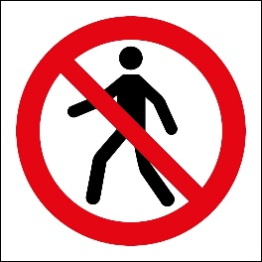 | 
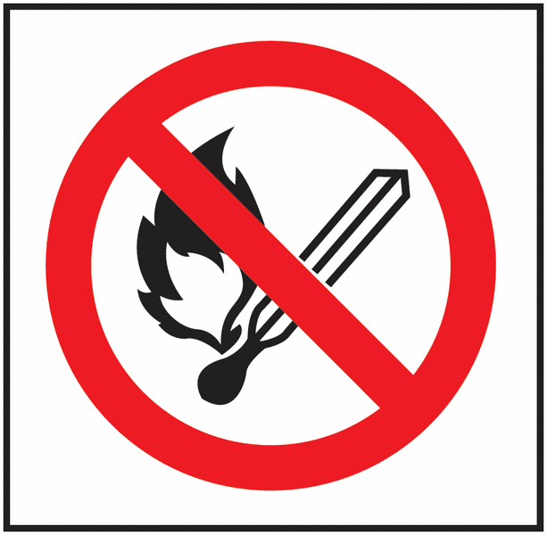 | 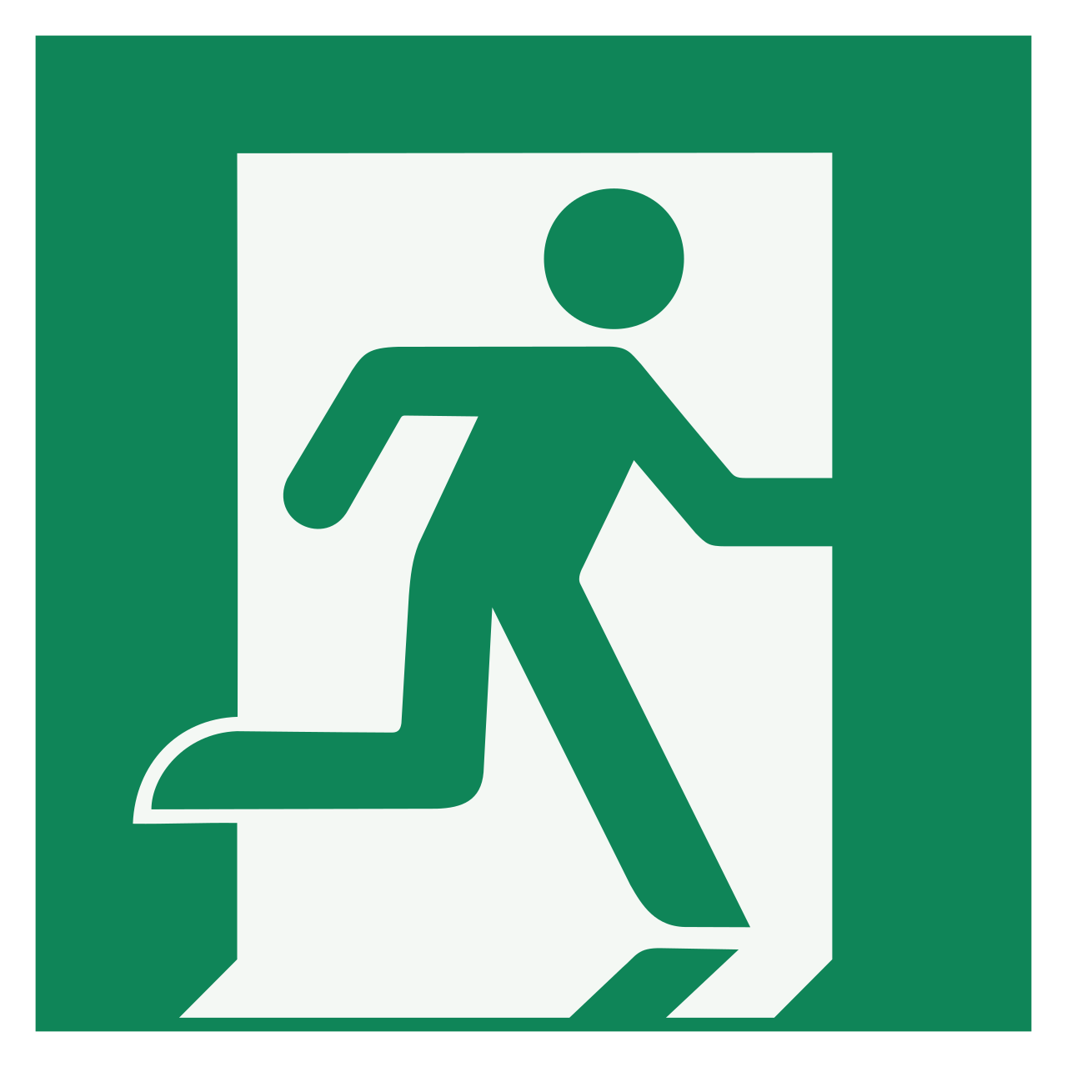 | 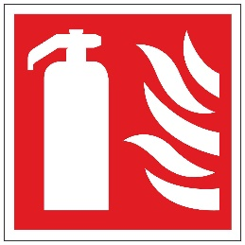
Who should you talk to if you see a health and safety risk while on work experience?
Remember: You will be informed of any health and safety rules you must adhere to at work.

- Outcomes of your work experience
Overall, write down the main thing you hope to achieve from your work experience:
Write down three things you’ll do to make the most of your work experience:
1.

2.

3.

Write down three key skills you would like to develop during your work experience:
1.

2.

3.

Who can help you to achieve your goals during your work experience?
1.

2.

You must inform your employer of any medical conditions or health issues you may have, especially if they could affect your ability to undertake certain tasks.

B) COMPLETE DURING WORK EXPERIENCE
- Daily log
Day one: What did you do?
Who did you meet? What was their role?

Who do you work with directly?

Write at least one thing that went well today.

Write at least one thing you are looking forward to about tomorrow.

Day two: What are your tasks?
Explain at least one task you did today.

Did you enjoy completing this task and why?

Day three: Mid-week reflection
Write one thing that’s gone well this week.

Write one thing you’d like to improve. Who could help you improve in this area?

Day four: What is your place of work like?
Describe what your workplace is like.

Is this type of workplace suited to you and why?

Day five: What did you learn?
Write down three things you learned this week.
1.

2.

3.

- Interview with employees
Complete this interview template with two employees with different job roles.

Employee interview one
1. What is your job role?
2. What are your main responsibilities?
3. What qualifications or training did you need for your job?
4. How long have you been in your job role?
5. What was the application process required for your job role?
6. What are the key skills required for your job?
7. What initially interested you about this role?
8. What is the best part of your job?
9. What is the most challenging part of your job?
10. What advice would you give to someone wanting to get into your industry?

Employee interview two
1. What is your job role?
2. What are your main responsibilities?
3. What qualifications or training did you need for your job?
4. How long have you been in your job role?
5. What was the application process required for your job role?
6. What are the key skills required for your job?
7. What initially interested you about this role?
8. What is the best part of your job?
9. What is the most challenging part of your job?
10. What advice would you give to someone wanting to get into your industry?

C) COMPLETE AFTER WORK EXPERIENCE
Work experience summary
  - Did you manage to achieve the goal you set before your work experience? Explain your answer.
  - Did you do the three things you planned to do to make the most of your work experience?
Explain your answer.
  - Did you develop the three skills you wanted to improve during your work experience?
Add at least one skill onto Unifrog using the Skills tool.
- Did you gain any additional skills you didn’t expect to develop during your work experience?
Add at least one skill onto Unifrog using the Skills tool.
- What was your favourite thing about work experience and why?
- What was the most challenging thing about your work experience and why?
- How has this work experience impacted your ideas for your future career journey?

Upload your completed journal to your Unifrog locker
Out of school hours Emergency Contact Number
07391 993 760

